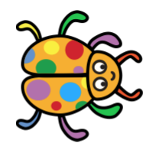

Shapes

Register/login at https://scratch.mit.edu
Remember to write down your password.


The Pen extension lets a sprite leave a trail when it moves.

- Click on the Add Extension button at the bottom left of the screen.
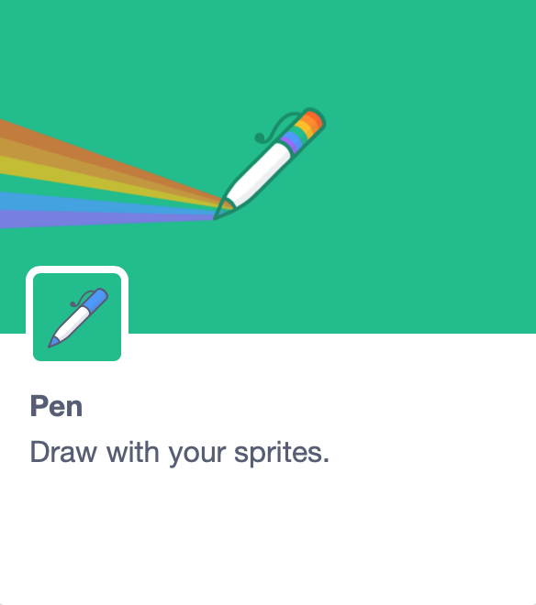
- Select the Pen extension. New Pen code blocks appear below the other code blocks.

- Choose a sprite that looks good when rotated. LadyBug1 is a good example.

- Add a when green flag clicked block, to run the code.
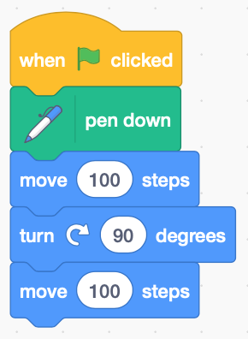
- From the new pen code blocks add pen down to start drawing. Add move 100 steps to draw a line.

To draw a shape like a square,
turn the sprite at the corners.

- Add turn ⟳ 90 degrees,
then move 100 steps again.
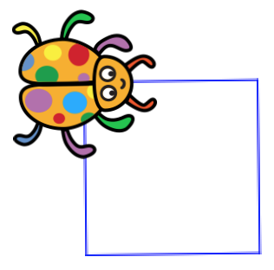
- Copy (right click the block, then duplicate) the turns and moves to draw a square.
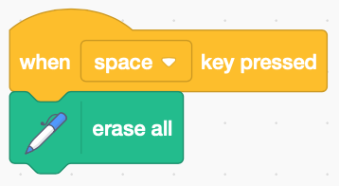
- You can erase the drawing with the erase all block. You can trigger this when the space key is pressed.

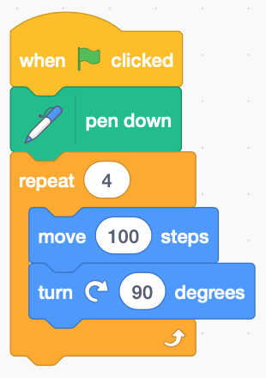
There's a lot of repetition in the square code. Replace it with a loop that repeats 4 times.

- Add a repeat block and change the loop count to 4 for each of the four sides.
Place move and turn inside the loop.

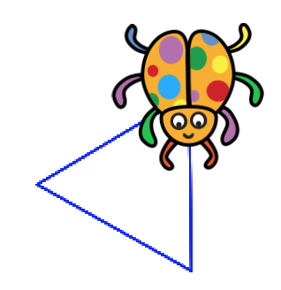
Can you draw a triangle? It has three sides so you must change the loop count.

The turn is 360 divided by the number of sides.
For a triangle this is 360 / 3 (the ‘/’ is division).

- Change the loop count and the turn to draw a triangle.

These shapes are called polygons.
Their external angles add up to 360 degrees.
A digon has only 2 sides – what does it look like?
What about shapes with more than 4 sides?
The more sides there are, the more it looks like a circle!
Remember to Save your code with a good name.
File > Save now

